Warning Check Fuel Fill Inlet E & F Display and B Display – CGEA1.3

Functional Description

The purpose of the Check Fuel Fill Inlet Warning is to inform the driver the fuel system cannot draw a vacuum for meeting emissions requirements because the capless fuel fill system inlet seal has not formed a proper seal due to debris or other reasons.

The Check Fuel Fill Inlet Warning correlates the FuelFillInlet_B_Dsply signal and the Operational_Mode to to determine when to display the Check Fuel Fill Inlet warning.

This Specification can be used with E & F or B Displays and is to be used for a Capless Fuel System. For a traditional fuel fill system use Warning Check Fuel Cap for E&F display or Fuel Cap Off RTT for B display.

Interfaces

Interface Context Diagram (I/O Block Diagram)
Figure 1 Warning –Check Fuel Fill Inlet Context Diagram

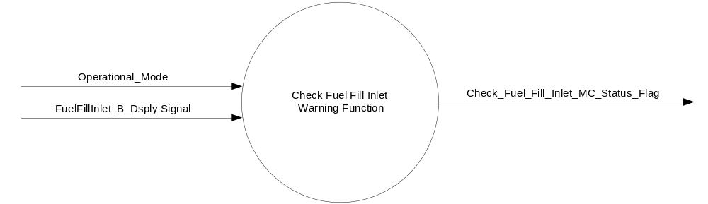

Inputs
      - INTERNAL:
    - Operational_Mode
- MUX message on the CAN Bus from ECM

- FuelFillInlet_B_Dsply Signal
Signal Name | Size  (bits) | Pos.  (bit) | Detail | Units | Res. | Offset | State Encoded | Min. | Max.
FuelFillInlet_B_Dsply | 1 | 39 |  | SED | 1 | 0 |  | 0  (0x0) | 1 (0x1)
 |  |  | No |  |  |  | 0x0
 |  |  | Yes |  |  |  | 0x1

Output
- Check_Fuel_Fill_Inlet_MC_Status_Flag, which is used to control the state of the Check Fuel Fill Inlet Message.

Function/Performance

Operational Modes

Mode | Differentiating Vehicle Conditions
Sleep Mode | Check_Fuel_Fill_Inlet_MC_Status_Flag = Inactive
Limited Mode | Check_Fuel_Fill_Inlet_MC_Status_Flag = Inactive
Normal Mode | Check_Fuel_Fill_Inlet_MC_Status_Flag = Inactive/Active
Crank Mode | Check_Fuel_Fill_Inlet_MC_Status_Flag = Inactive/Active

The above table references the setting of the Warning flag as per this section. However, the actual warning display operational modes are displayed in the Message Center section of this SPSS.

Voltage Levels

Refer to the Cluster Features Table located in the Operational Modes and Voltage Range Strategies Section of this SPSS.

Human-Machine Interface

Visual

Indicator Graphics / Display Format
Message Center Text Warning Message as defined in section 1.3.5.7 of this document.

1.3.3.1.2 Indicator Color Coordinates

Reference section COLOR & ILLUMINATION REQUIREMENTS (GRAPHICS).

Audio

None

Switch Control Logic

None.

System Accuracy

Within 100 msec of receiving a message that results in a change of state the cluster will update the output flag to the proper state.

Operation: Performance and Functional

Subsystem Algorithm Flowchart / State Diagram

- State Matrix for Check Fuel Fill Inlet Warning
Operational_Mode | FuelFillInlet_B_Dsply Signal | Check_Fuel_Fill_Inlet_MC_  Status_Flag
Normal or Crank | Yes (0x1) | Active
All Other Cases |  | Inactive

Table 1.3 Check Fuel Fill Inlet MC Status Flag to MC Warning Message ID
Check_Fuel_Fill_Inlet_MC_Status_Flag | MC System Check Message ID
Inactive | None
Active | W781 (Check Fuel Fill Inlet)

Table 1.4 System Check Function for Check Fuel Fill Inlet Warnings
Check_Fuel_Fill_Inlet_MC_Status_Flag | MC System Check Message ID
Inactive | None
Active | W781 (Check Fuel Fill Inlet)

Operation Description (supports algorithm flowchart /state diagram)

- Check_Fuel_Fill_Inlet_MC_Status_Flag = Active, Warning ID W781 will be Active.
- For definition of how the Message Center arbitrates and displays Active warnings, see the Warning / Alert Display Logic Diagram, located in the Message Center – X Display with W Button Interface section of this SPSS (where X and W are appropriate values in this document).

Function Safety Classification (EMC)

Class B

Memory Storage
Parameter Name | Description | Value at  Battery Connect | Value at  Module Wake-up
FuelFillInlet_B_Dsply Signal | CAN Signal sent from the ECM | No (0x0) | No (0x0)
Check_Fuel_Fill_Inlet_MC_Status_Flag | State variable used by M/C Warning Arbitrator | INACTIVE | INACTIVE
Operational_Mode | 4 state indicator for cluster operational mode | Limited | Limited or Normal or Crank

Prove Out

No.

Reconfigurable Telltale

No.

Message Center Msg

Warning message ID W781 as defined in the Text Message List section of this SPSS.

Error Handling

Missing Message Strategy

The signals will be declared missing as per the Diagnostics section of this SPSS.

DTCs states and history will be determined as per the Diagnostics section of this SPSS.

Diagnostics

Self Test

None

Engineering Test Mode

Not Applicable

Part II Performance

Supported Diagnostic Trouble Codes (DTCs)

DTC | Description
C10000 | Lost communication with ECM/PCM

Reference Specification

IS-0001 WARNINGS/INDICATORS/DISPLAYS PROVEOUT
IS-0052 OPERATING VOLTAGES - FUNCTIONAL/PERFORMANCE
IS-0069 FUNCTIONAL IMPORTANCE CLASS
IS-0324 WINDSHIELD & OTHER REFLECTIONS
IS-0327 WARNING INDICATOR EVALUATION
IS-0379 NORTH AMERICAN WARNINGS AND INDICATORS STRATEGY

IL-0017 TELLTALE AND INTERIOR ILLUMINATION – COLOR AND INTENSITY
IL-0019 GENERAL ILLUMINATION DIMMING
IL-0021 CRAFTSMANSHIP – DISPLAYS
IL-0022 GENERAL ILLUMINTATION COLOR
IL-0023 CLARITY/LEGIBILITY/READABILITY/VISUAL CONTRAST
IL -0043 OPERATIONAL ENVIRONMENT FUNCTIONALITY
IL -0045 COLOR
IL -0047 TELLTALE, INDICATOR AND DISPLAY LIGHT INTENSITY
IL -0048 ILLUMINATION ACCEPTABILITY

03-0661 PLACEMENT: CONTROL AND DISPLAY LOCATIONS
03-0662 PLACEMENT: LOGICAL GROUPING FUNCTION AND USAGE
03-0664 PLACEMENT: DOWN VISION TO COMPONENTS WITH HIGH VISUAL DEMAND
03-0665 PLACEMENT: EXPECTED LOCATIONS OF CONTROLS AND DISPLAYS VDS
03-0670 INTERIOR VISIBILITY
03-0671 INTERIOR VISIBILITY: REFLECTIONS FROM COMPONENTS & SURFACES
03-0672 INTERIOR VISIBILITY: REFLECTIONS IN DISPLAYS
03-0673 INTERIOR VISIBILITY: VISUAL OBSCURATIONS
03-0674 INTERIOR VISIBILITY: ILLUMINATION CONTROLS / DISPLAYS
03-0675 INTERIOR VISIBILITY: VEILING GLARE
03-0677 INTERIOR VISIBILITY: SUNLIGHT WASHOUT
03-0681 IDENTIFICATION: CHARACTER AND SYMBOL SIZE
03-0682 IDENTIFICATION: LEGIBILITY
03-0685 IDENTIFICATION: SYMBOLS, ABBREV FOR CONTROL
03-0721 LOGIC OF OPERATION: OPERATIONAL STEREOTYPES
03-0722 LOGIC OF OPERATION: INTERPRETATION
03-0723 LOGIC OF OPERATION: USE OF SYSTEMS WITH VISUAL DISPLAYS

Revision History
SPSS Module Revision History

Revision  Level | Name | Change Description | Date
1.0 | V. Patel | Updated for CGEA 1.3 based on CGEA STSS v1.0  Section 1.2.2 – Removed table referencing the HS-CAN message that contains the input signals.  Section 1.4 – Rewritten. Deleted references of specific missing message flags and timer.  Section 1.5.3 – Deleted DTC logging criteria from the table. | 4/13/2010

